Ideation Phase
Brainstorm & Idea Prioritization Template

Date | 18-febrauary 2026
Team ID | LTVIP2026TMIDS53168
Project Name | TransLingua : AI-Powered Multi-Language Translator
Maximum Marks | 4 Marks

Brainstorm & Idea Prioritization Template:
To develop TransLingua, we brainstormed features such as real-time voice-to-text, document file translation, and offline dictionary support to enhance global communication. After evaluating these ideas based on technical feasibility and user impact, we prioritized the integration of the Gemini-1.5-flash model for its superior speed and linguistic accuracy. We categorized our goals into UI responsiveness, API security, and language diversity, focusing on a streamlined web interface for immediate accessibility. By prioritizing a secure environment-variable architecture, we ensured the app is robust enough for professional use while remaining user-friendly. These selected priorities offer the most scalable and high-impact solution for bridging language gaps in real-time.Reference: https://www.mural.co/templates/brainstorm-and-idea-prioritization
Step-1: Team Gathering, Collaboration and Select the Problem Statement
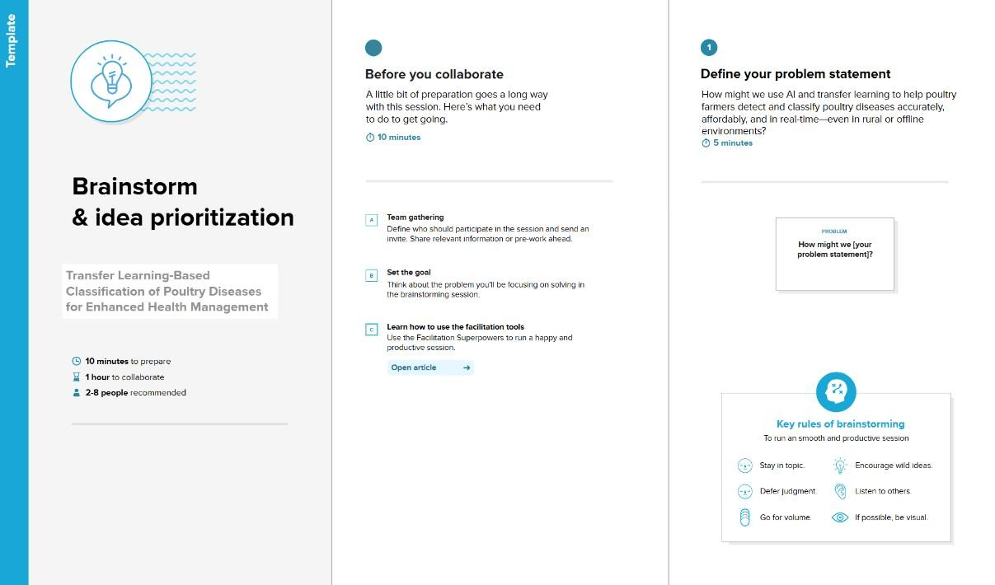

Step-2: Brainstorm, Idea Listing and Grouping
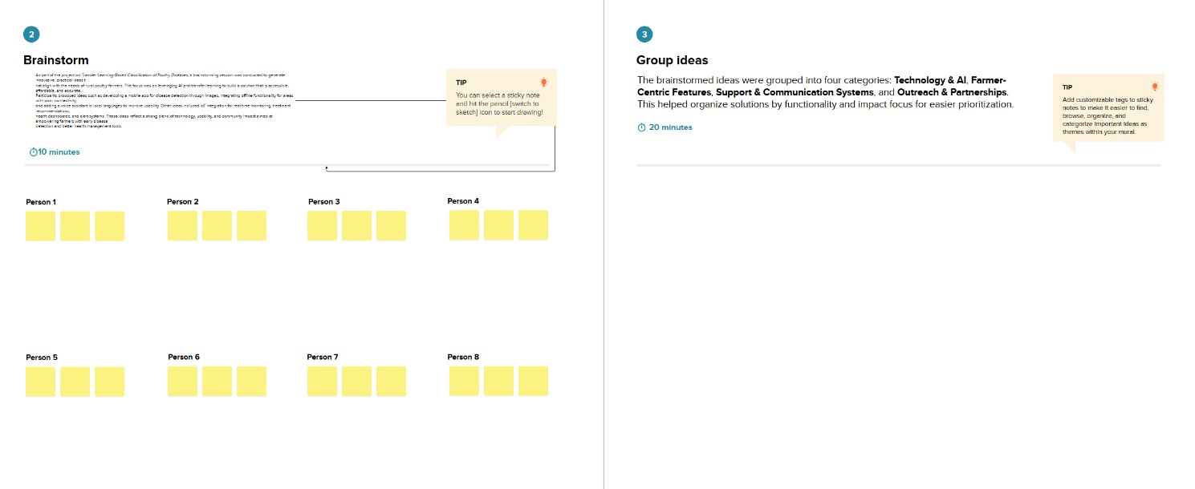
Step-3: Idea Prioritization
